FARM MANAGEMENT SYSTEM

P.EAGASAYANI [Reg No:30424U09006]
S.GOPIKA [Reg No:30424U09007]
V.HEMALATHA [Reg No:30424U09008]
B.HEMAVATHI [Reg No:30424U09009]
V.KAMALI [Reg No:30424U09011]

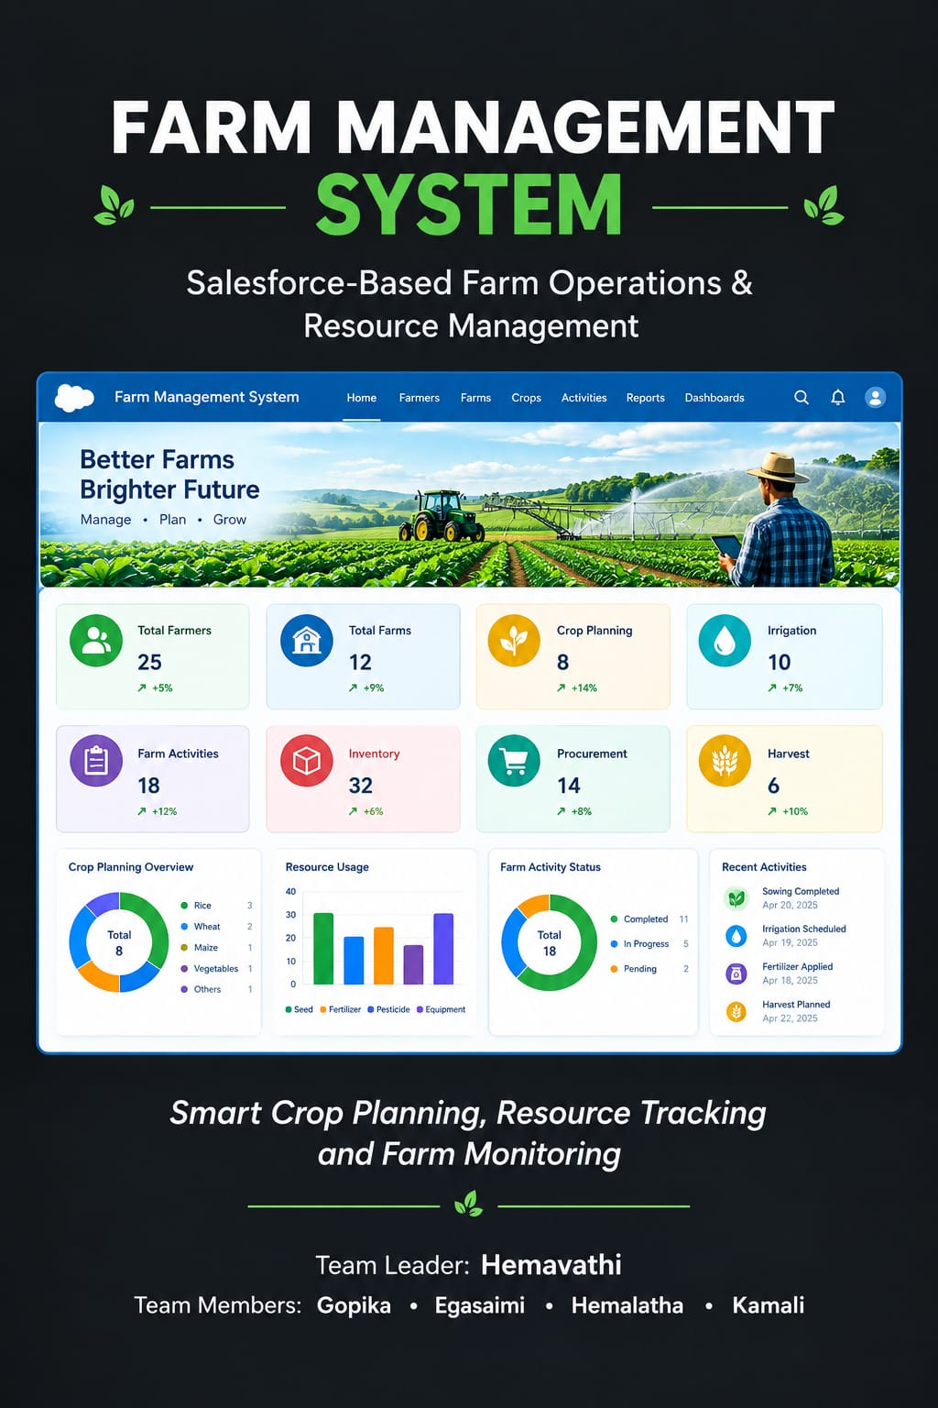
FARM MANAGEMENT SYSTEM

User Story:
In the Farm Management System (FMS), as a farmer, I want to use a centralized Salesforce-based platform to manage my farming operations, field activities, crop planning, and farm resources so that I can maintain all my agricultural activities in one organized system. I want to create and update field information, crop selection, sowing schedules, irrigation activities, and farming tasks through a simple and user-friendly interface so that I can plan and monitor my daily farm operations effectively. I also want to maintain details about seeds, fertilizers, pesticides, equipment, and labour used for different farming activities so that I can keep track of the resources required for each crop. Additionally, I want to record important farming activities and their completion status so that I can identify pending tasks and manage cultivation activities on time. I also want the system to provide reports and dashboards showing crop progress, resource usage, completed activities, and farm operations so that I can understand the current status of my farm. This system will help reduce manual record keeping, improve farm planning, organize daily agricultural activities, track resource usage, and support efficient farm operation management.
- INTRODUCTION

Project Overview :
The Farm Management System (FMS) is a Salesforce-based application designed to digitize and streamline agricultural operations. It manages data related to fields, crops, sowing schedules, irrigation activities, farming tasks, and farm resources while providing useful insights through reports and dashboards. The system helps farmers organize their daily agricultural activities, monitor crop progress, track resource usage, and manage farming operations efficiently.

  - Purpose:
The purpose of the Farm Management System (FMS) is to provide a centralized Salesforce-based platform for managing farming operations, field activities, crop planning, and farm resources. The system helps farmers maintain field details, crop selection, sowing schedules, irrigation activities, farming tasks, and resource information in an organized manner. It also helps track activity completion, pending tasks, crop progress, and resource usage through reports and dashboards. The system reduces manual record keeping, improves farm planning, organizes daily agricultural activities, and supports efficient

2. IDEATION PHASE

2.1 Problem Statement (Customer Problem Statement Template)

PS | I am (customer) |  | I’m trying to | But |  | Because | Which makes me feel
PS-1 | Farmer |  | Manage farm operations and field activities | Farming records are difficult to organize |  | Records are maintained manually | Confused and frustrated
PS-2 | Farmer |  | Plan crops, sowing schedules, and irrigation activities | Activities may be missed or delayed |  | There is no centralized system to monitor them | Stressed and concerned
PS-3 | Farmer |  | Maintain seed, fertilizer, pesticide, equipment, and labour details | Resource usage is difficult to track |  | Resource details are maintained manually | Confused and inefficient
PS-4 | Farmer |  | Track farming activities and completion status | Pending tasks are difficult to identify |  | Activity information is not organized in one place | Concerned and dissatisfied
PS-5 | Farmer | Monitor crop progress and farm |  | Current farm status is difficult to understand | Information is scattered across different records |  | Frustrated and concerned
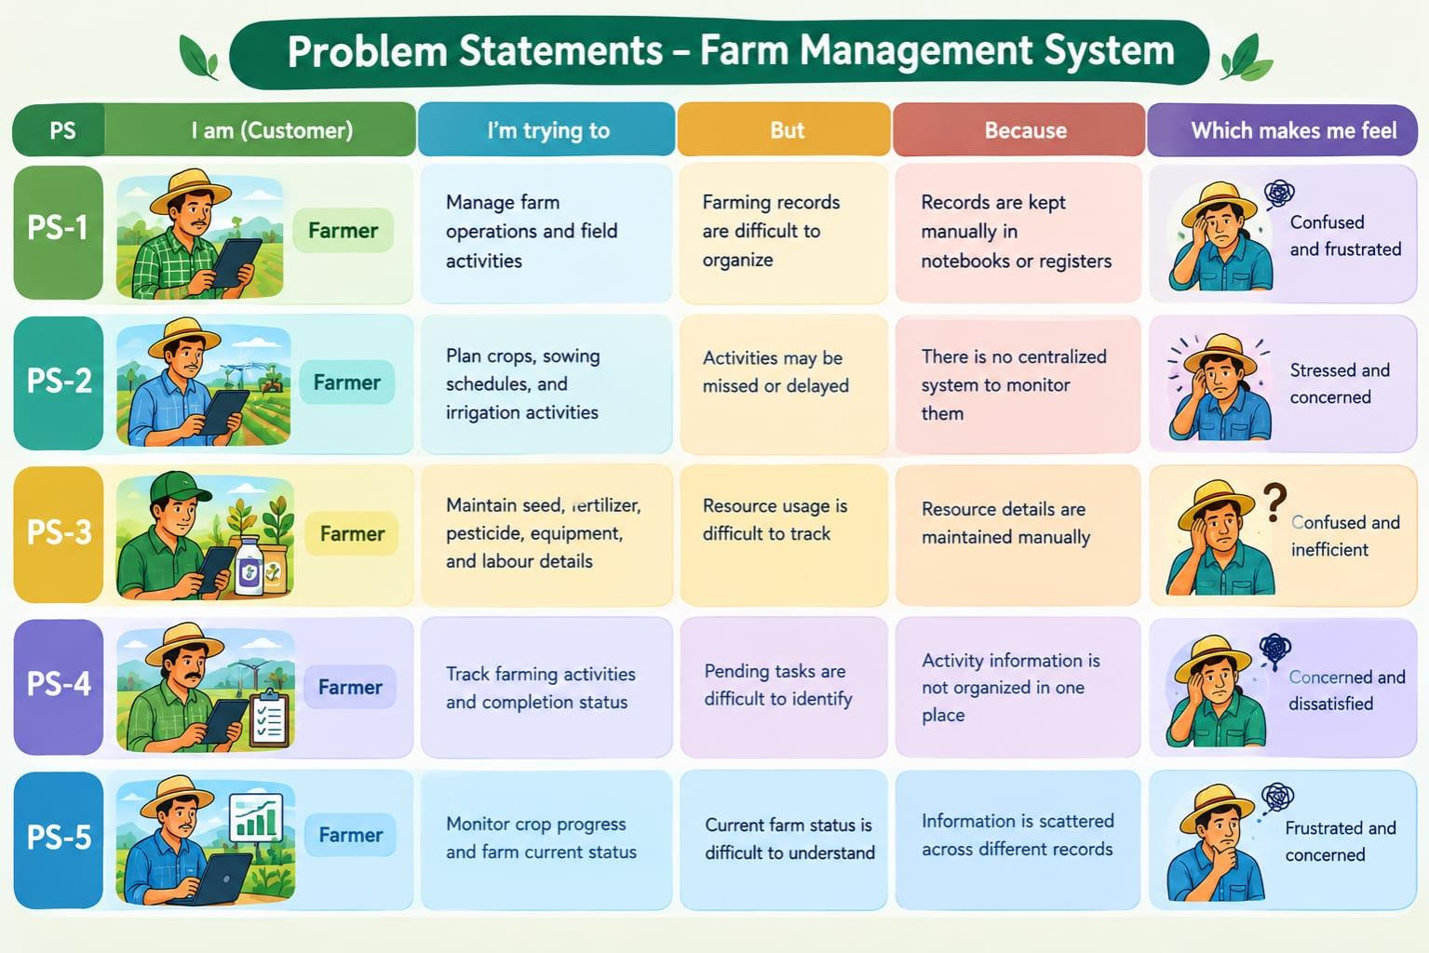

Empathy Map Canvas

Target Users:

Farmer

Empathy Analysis

Think & Feel: Need an organized and easy way to manage farm activities, crop planning, and resources.

Hear: Suggestions and information related to farming activities, crop cultivation, irrigation, and resource management.

See: Farm records, field details, crop schedules, farming tasks, and resource information maintained manually or in separate records.

Say & Do: Record field information, plan crops, manage sowing and irrigation activities, track farming tasks, and maintain resource details.

Pain: Manual record keeping, difficulty in tracking pending activities, resource usage, crop progress, and daily farm operations.

Gain: Centralized farm management, organized agricultural records, better task tracking, resource monitoring, and useful reports and dashboards.

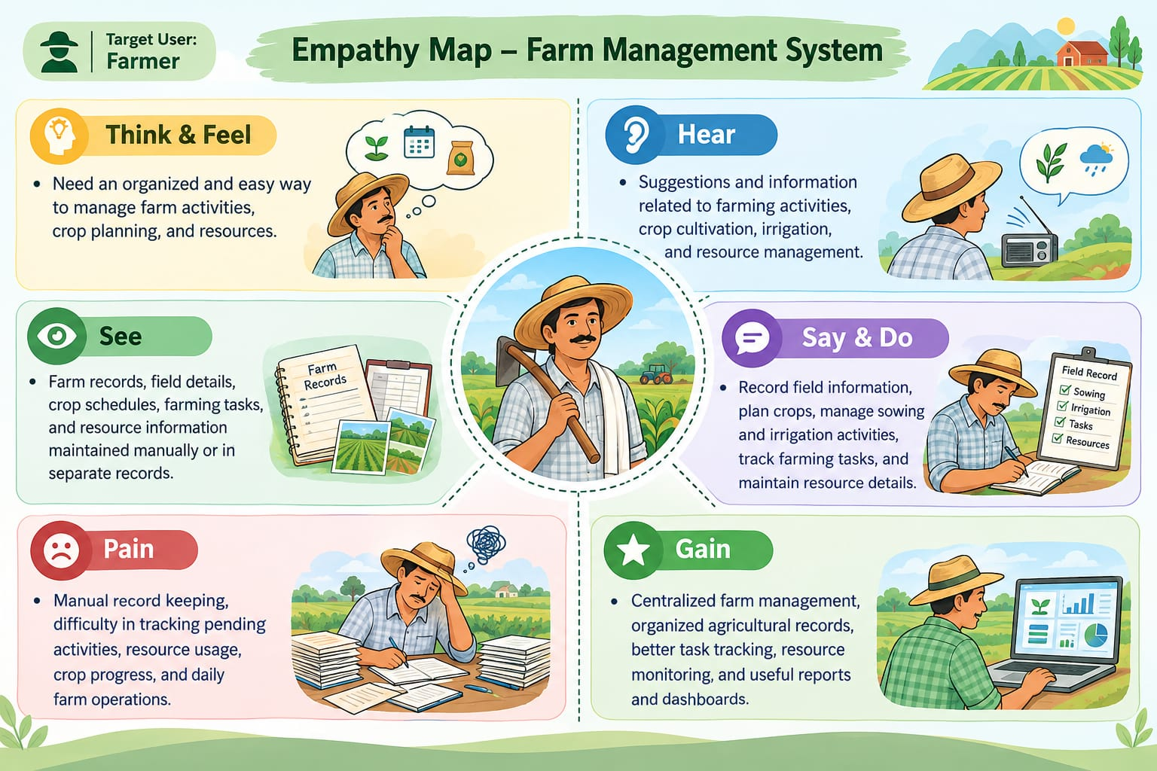

2.3 Brainstorming

Brainstormed Ideas

Manual management of field and crop records

Excel-based farm activity and resource management

Separate records for sowing and irrigation activities

Mobile-based farming task and resource tracking

Selected Ideas

Salesforce-based centralized Farm Management System

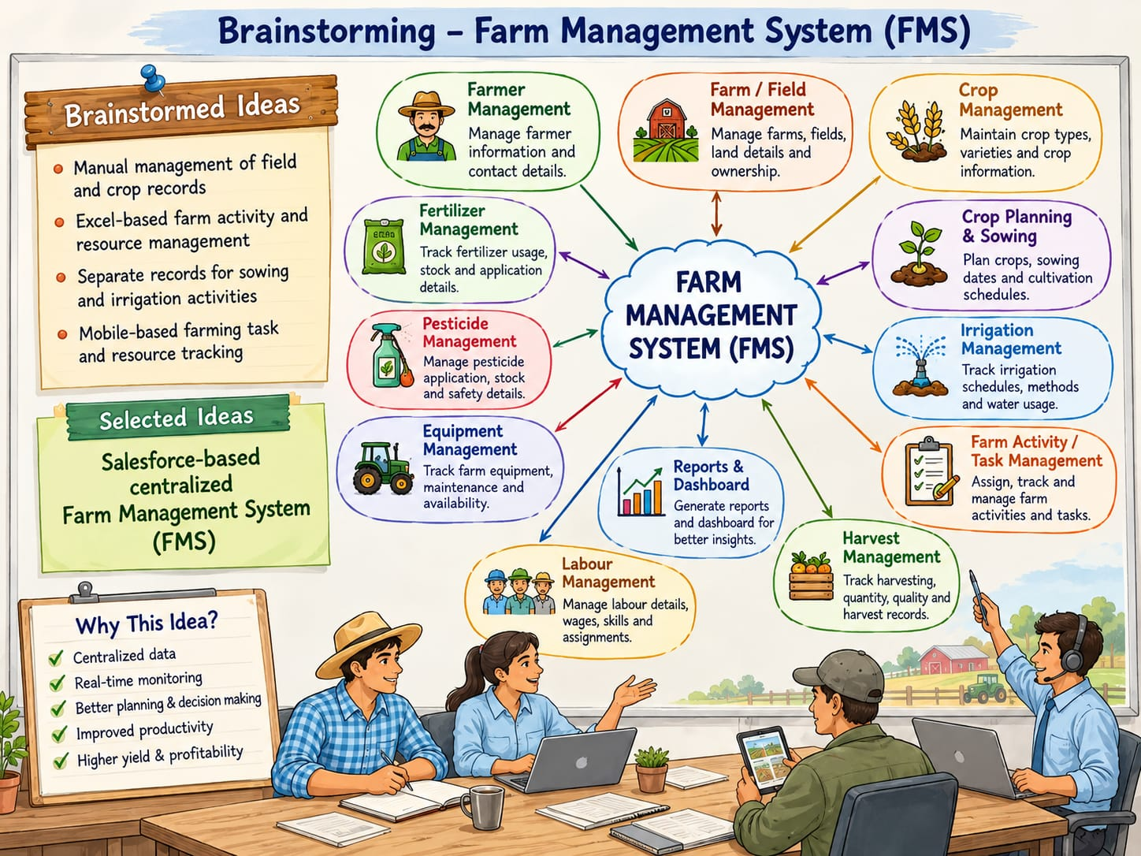

3. REQUIREMENT ANALYSIS PHASE

3.1 Customer Journey Map

Stages:

1. Login

2. Access Farm Management App

3. Register Farmer and Farm Details

4. Manage Crops, Seeds, and Fertilizers

5. Manage Irrigation, Pesticides, and Farm Activities

6. Manage Labour, Equipment, and Resources

7. Manage Harvest and Inventory

8. Generate Reports and Dashboards

9. Analyze Results

10. Decision Making
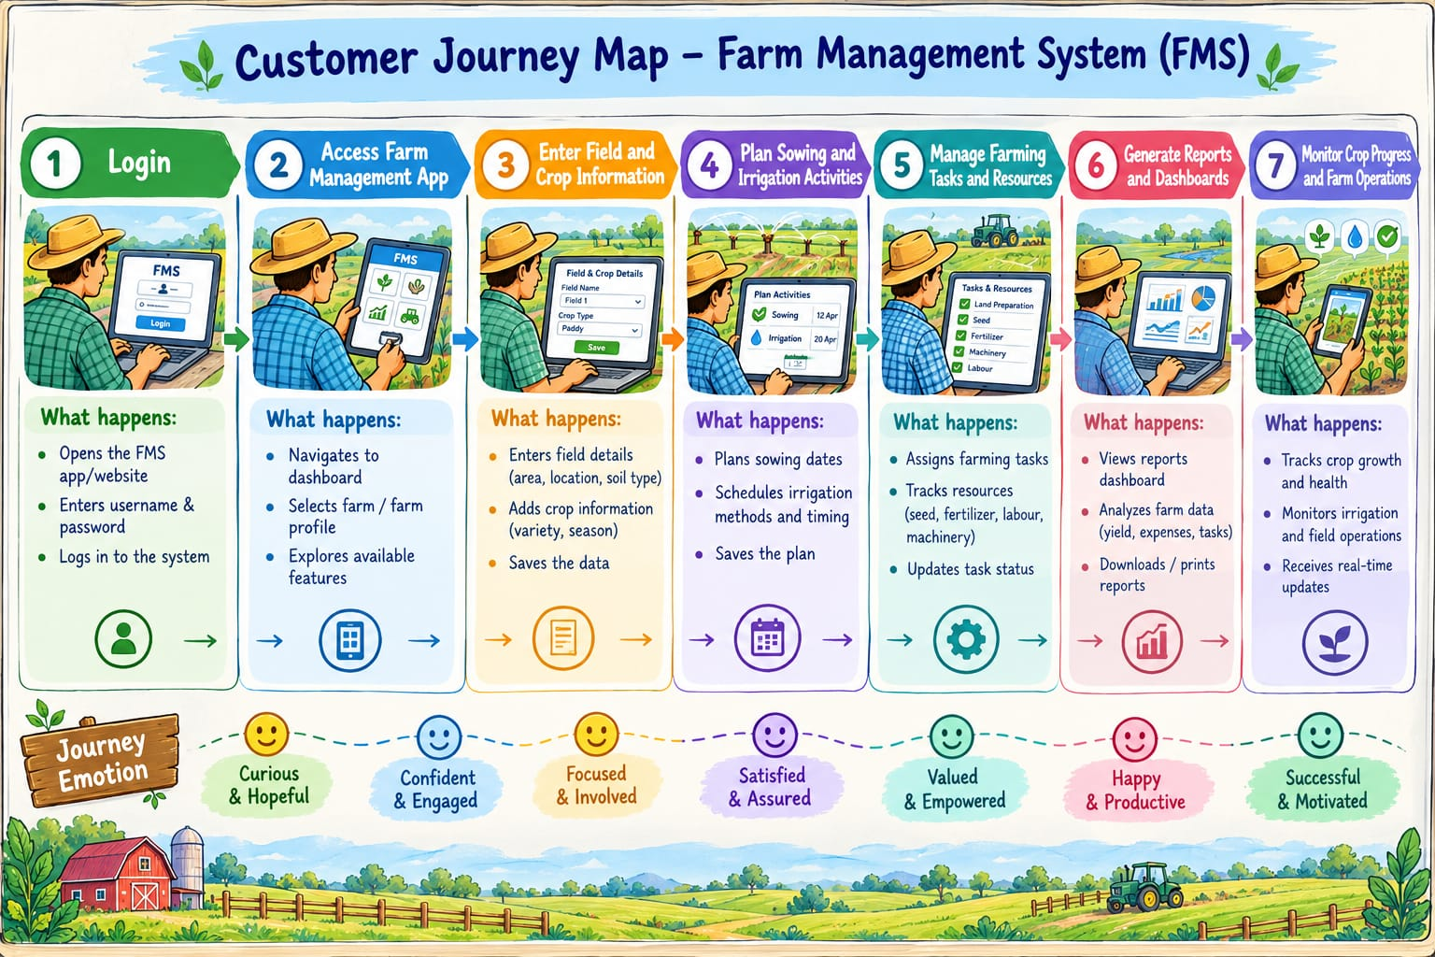

3.2 Solution Requirements

Functional Requirements
FR-1 | Requirement
FR-1 | User Authentication
FR-2 | Field and Crop Management
FR-3 | Sowing and Irrigation Management
FR-4 | Farming Activity and Task Management
FR-5 | Resource Management
FR-6 | Report Generation
FR-7 | Dashboard View

Non-Functional Requirements
NFR | Description | Example
Usability | Easy to use interface | Salesforce Lightning UI
Security | Protect farm data | User Profiles & Permissions
Reliability | Ensures data accuracy | Salesforce data storage
Performance | Fast data access | Quick report generatiion
Availability | Access to the system | Cloud-based Salesforce access
Scalability | Support future growth | Add More farms/users
Maintainability | Easy to update and manage | Salesforce object and field customization

3.3 Data Flow Diagram

Data Flow:

User → Salesforce UI → Custom Objects (Farmer, Farm, Crop, Crop Plan, , Irrigation, Farm Activity, Seeds, Fertilizers, Pesticides, Equipment, Labours, Harvest, Resources, Inventories, procurement) → Validation Rules → Relationships → Reports → Dashboards
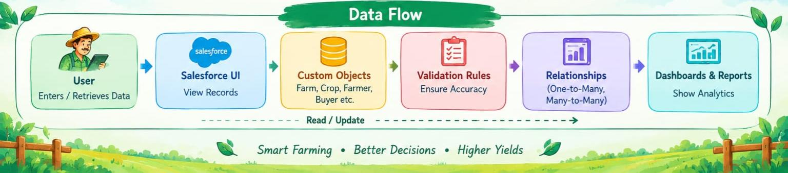

3.4 Technology Stack

Layer | Technology
Frontend | Salesforce Lightning UI
Backend | Salesforce Platform
Database | Salesforce Cloud
Automation | Validation Rules
Analytics | Reports & Dashboards

4. PROJECT DESIGN PHASE

4.1 Problem–Solution Fit

The Farm Management System replaces manual farm records with centralized management of field, crop, schedule, activity, and resource information. Salesforce provides organized cloud-based data storage, while reports and dashboards help farmers monitor crop progress, resource usage, completed activities, and farm operations. This helps reduce manual record keeping and supports better planning and monitoring of daily agricultural activities.

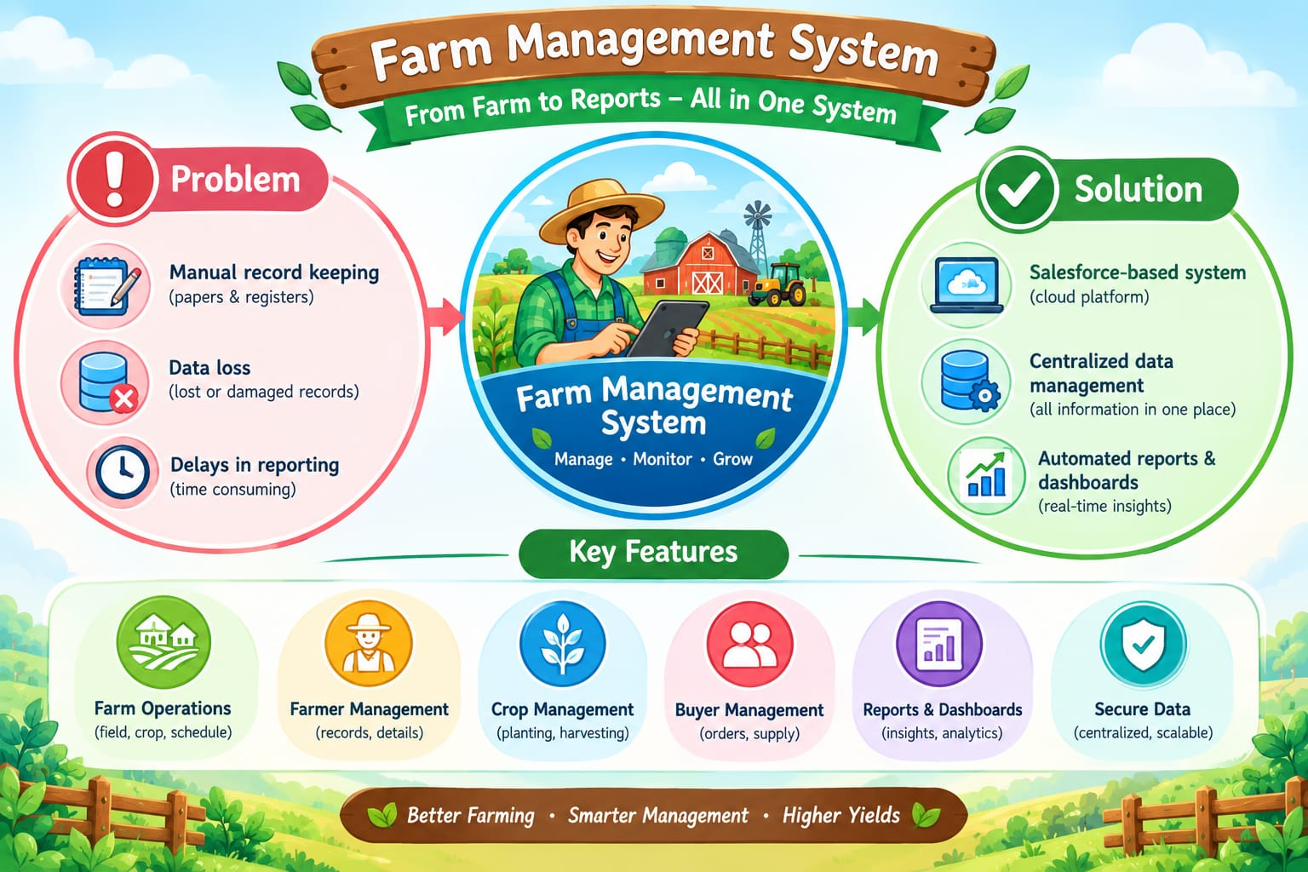

4.2 Proposed Solution

Functional Reqirements

Parameter | Description
Problem | Manual management of field information, crop planning, farming activities, and resource records can make farm operations difficult to organize.
Solution | Salesforce-based Farm Management System with centralized management of fields, crops, farming activities, tasks, and resources.
Innovation | Centralized digital management of sowing, irrigation, farming activities, resource usage, and task completion.
Impact | Improved farm planning, organized daily activities, better resource tracking, and easier monitoring of crop progress.
Business Model | Digital platform for organizing and managing farming operations.
Scalability | Supports the management of different fields, crops, farming activities, resources, and farm operations in one centralized system

4.3 Solution Architecture

Architecture Layers

Presentation Layer – Salesforce Lightning UI

Application Layer – Validation Rules and Relationships

Data Layer – Custom Objects for Fields, Crops, Schedules, Activities,and resources

Analytics Layer – Reports and Dashboards

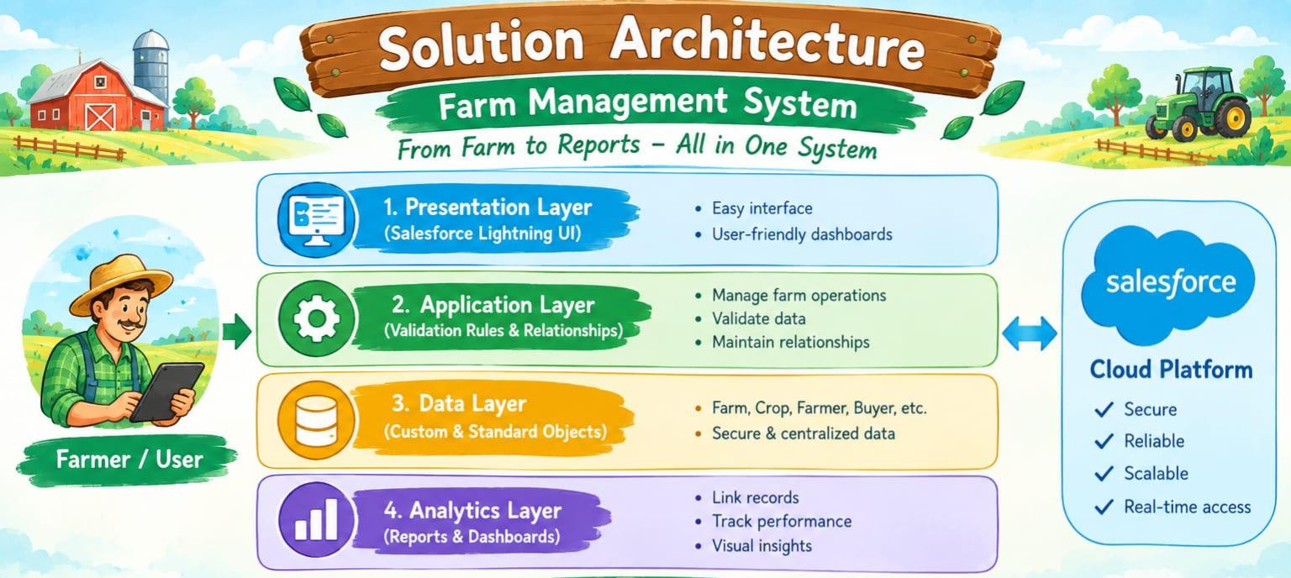

5. PROJECT PLANNING & SCHEDULING

5.1 Project Planning

The project planning phase focuses on developing and configuring the Salesforce-based Farm Management System according to the farmer's requirements. The major activities include:

● Created Salesforce Developer Org

● Developed custom objects for field, crop, schedule, activity, and resource management

● Configured tabs and Lightning App

● Created fields and relationships

● Configured user access and sharing settings

● Created farming activity and resource records

● Developed reports and dashboards

● Conducted testing and reviews

Product Backlog, Sprint Schedule, and Estimation

Sprint | Functional Requirement  (Epic) | User story number | User story/Task story | Points | Priority | Team members
Sprint-1 | Developer setup | USN-1 | As a farmer, I want a Salesforce-based Farm Management System so that I can manage my farming operations in one centralized platform. | 3 | High | Member 1
Sprint-2 | Field management | USN-2 | As a farmer, I want to create and update field information so that I can maintain details about different farming fields | 5 | High | Member 2
Sprint-2 | Crop planning | USN-3 | As a farmer, I want to maintain crop selection and planning details for each field so that I can organize cultivation activities. | 5 | High | Member 3
Sprint-3 | Sowing & Irrigation | USN-4 | As a farmer, I want to manage sowing schedules and irrigation activities so that important cultivation activities can be planned and monitored on time. | 5 | High | Member 4
Sprint-3 | Farm activities | USN-5 | As a farmer, I want to record farming activities and their completion status so that I can identify pending tasks and monitor daily operations. | 3 | High | Member 4
Sprint-4 | Resource Management | USN-6 | As a farmer, I want to maintain seed, fertilizer, pesticide, equipment, and labour details so that I can track the resources used for farming activities. | 5 | High | Member 2
Sprint-5 | Reports | USN-7 | As a farmer, I want reports showing crop progress, resource usage, and completed activities so that I can monitor the current status of my farm operations. | 4 | High | Member 3
Sprint-6 | Dashboards | USN-8 | As a farmer, I want dashboards showing crop progress, resource usage, and farm activities so that I can view important farm information in an organized manner | 4 | Medium | Member 3

Project Tracker,Velocity & Burndown(4 Marks)

Sprint | Total Story Points | Duration | Sprint start date | Sprint end date  (Planned) | Story points completed  (as on planning end date) | Sprint release date(actual)
Sprint-1 | 3 | 6 days | 24 oct 2022 | 29 oct 2022 | 3 | 29 oct 2022
Sprint-2 | 10 | 6 days | 31 oct 2022 | 31 oct 2022 | 10 | 05 nov 2022
Sprint-3 | 8 | 6 days | 07 nov 2022 | 07 nov 2022 | 8 | 12 nov 2022
Sprint-4 | 5 | 6 days | 14 nov 2022 | 14 nov 2022 | 5 | 19 nov 2022
Sprint-5 | 4 | 6 days | 21 nov 2022 | 21 nov 2022 | 4 | 26 nov 2022
Sprint-6 | 4 | 6 days | 28 nov 2022 | 28 nov 2022 | 4 | 03 dec 2022

6. PROJECT DEVELOPMENT PHASE

Project Description
The Farm Management System (FMS) is a Salesforce-based application developed to manage agricultural operations. It provides modules for farmers, farms, crops, crop planning, irrigation, farm activities, seeds, fertilizers, pesticides, equipment, labour, harvesting, resources, inventory, and procurement. The system also provides reports and dashboards to monitor farm operations and support decision-making.

Milestone 1 – Salesforce:

What is Salesforce?
Salesforce is a cloud-based platform used to develop applications, manage data, and automate business processes. It provides tools such as custom objects, fields, relationships, reports, and dashboards.

Activity 1:

Creating a Salesforce Developer Org
A Salesforce Developer Org is used to develop and test applications.
- Open a web browser.
- Search for developer.salesforce.com/signup.
- Enter the required registration details.
- Provide a unique username and email address.
- Click Sign Me Up.
- Verify the account using the email received from Salesforce.
- Create a password and save the account.
- Open login.salesforce.com.
- Enter the username and password.
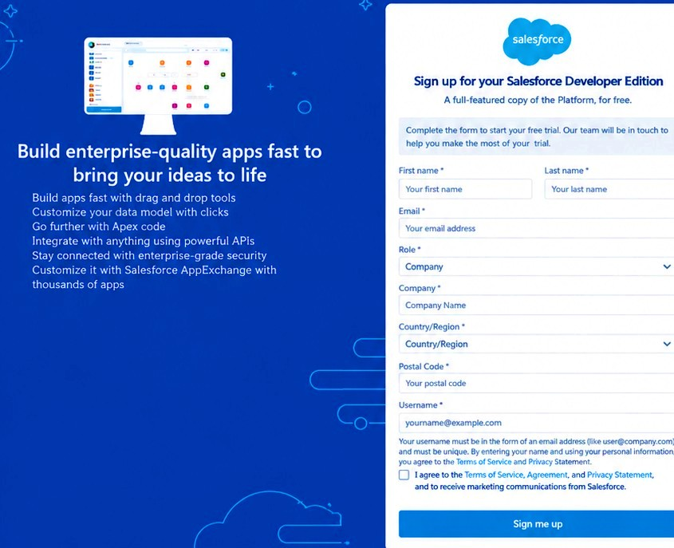
- Click Log In to access the Salesforce homepage.
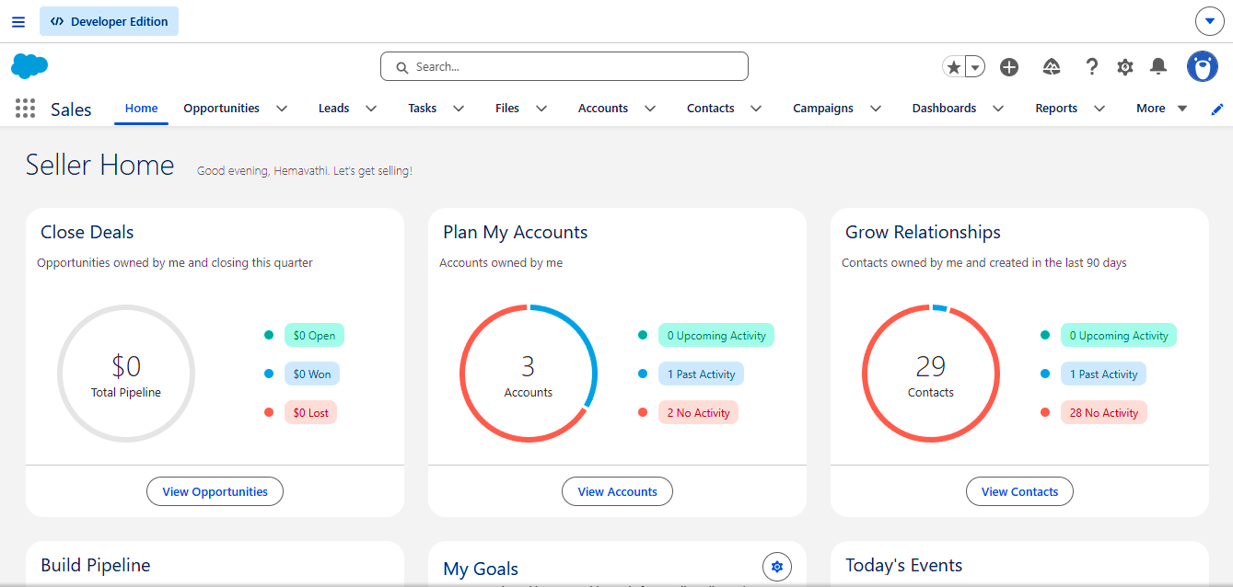

Milestone 2 – Custom Objects

What is an Object?
A Salesforce object is used to store information in the form of records and fields. Custom objects allow users to create data structures according to application requirements.

Custom Objects Used in the Application
The Farm Management System uses the following 15 custom objects:
- Farmer
- Farm
- Crop
- Crop Plan
- Irrigation
- Farm Activity
- Seed
- Fertilizer
- Pesticide
- Equipment
- Labour
- Harvest
- Resource
- Inventory
- Procurement

Activity 1:

Creating the Farmer Object
- Open Setup using the gear icon.
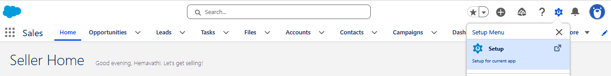
- Select Object Manager.
- Click Create and select Custom Object.
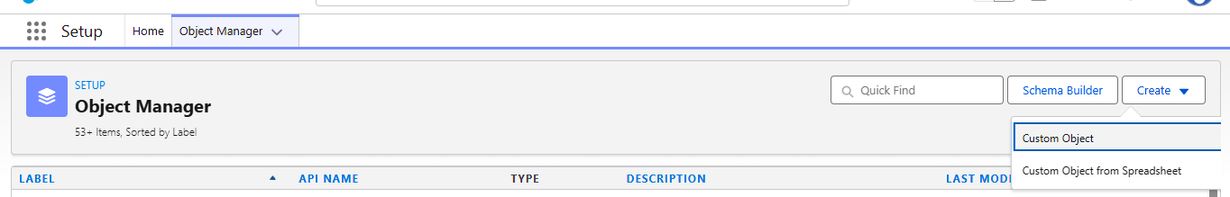
- Enter the Label as Farmer.
- Enter the Plural Label as Farmers.
- Enter the Record Name as Farmer Name.
- Select Text as the data type.
- Enable Allow Reports and Allow Search.
- Select the required object options.
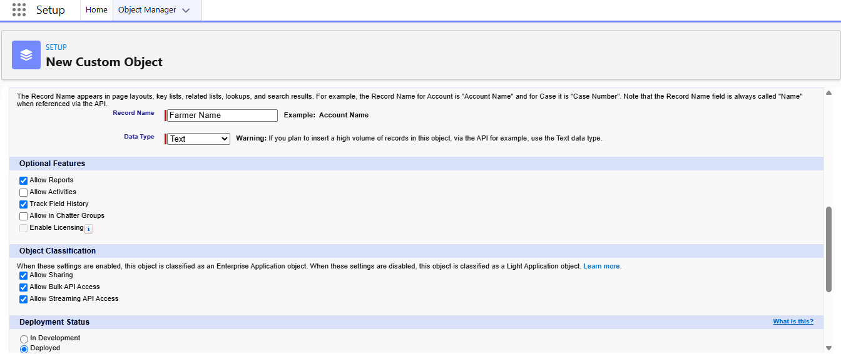
- Click Save.

Activity 2:

Creating the Farm Object
- Open Setup and select Object Manager.
- Click Create and select Custom Object.
- Enter the Label as Farm.
- Enter the Plural Label as Farms.
- Enter the Record Name as Farm Name.
- Select Text as the data type.
- Enable Allow Reports and Allow Search.
- Select the required object options.
- Click Save.

Activity 3:

Creating the Crop Object
- Open Setup and select Object Manager.
- Click Create and select Custom Object.
- Enter the Label as Crop.
- Enter the Plural Label as Crops.
- Enter the Record Name as Crop Name.
- Select Text as the data type.
- Enable Allow Reports and Allow Search.
- Select the required object options.
- Click Save.

Activity 4:

Creating the Crop Plan Object
- Open Setup and select Object Manager.
- Click Create and select Custom Object.
- Enter the Label as Crop Plan.
- Enter the Plural Label as Crop Plans.
- Enter the Record Name as Crop Plan.
- Select Text as the data type.
- Enable Allow Reports and Allow Search.
- Click Save.

Activity 5:

Creating the Irrigation Object
- Open Setup and select Object Manager.
- Click Create and select Custom Object.
- Enter the Label as Irrigation.
- Enter the Plural Label as Irrigations.
- Enter the Record Name as Irrigation Name.
- Select Text as the data type.
- Enable Allow Reports and Allow Search.
- Click Save.

Activity 6:

Creating the Farm Activity Object
- Open Setup and select Object Manager.
- Click Create and select Custom Object.
- Enter the Label as Farm Activity.
- Enter the Plural Label as Farm Activities.
- Enter the Record Name as Activity Name.
- Select Text as the data type.
- Enable Allow Reports and Allow Search.
- Click Save.

Activity 7:

Creating the Seed Object
- Open Setup and select Object Manager.
- Click Create and select Custom Object.
- Enter the Label as Seed.
- Enter the Plural Label as Seeds.
- Enter the Record Name as Seed Name.
- Select Text as the data type.
- Enable Allow Reports and Allow Search.
- Click Save.

Activity 8:

Creating the Fertilizer Object
- Open Setup and select Object Manager.
- Click Create and select Custom Object.
- Enter the Label as Fertilizer.
- Enter the Plural Label as Fertilizers.
- Enter the Record Name as Fertilizer Name.
- Select Text as the data type.
- Enable Allow Reports and Allow Search.
- Click Save.

Activity 9:

Creating the Pesticide Object
- Open Setup and select Object Manager.
- Click Create and select Custom Object.
- Enter the Label as Pesticide.
- Enter the Plural Label as Pesticides.
- Enter the Record Name as Pesticide Name.
- Select Text as the data type.
- Enable Allow Reports and Allow Search.
- Click Save.

Activity 10:

Creating the Equipment Object
- Open Setup and select Object Manager.
- Click Create and select Custom Object.
- Enter the Label as Equipment.
- Enter the Plural Label as Equipment.
- Enter the Record Name as Equipment Name.
- Select Text as the data type.
- Enable Allow Reports and Allow Search.
- Click Save.

Activity 11:

Creating the Labour Object
- Open Setup and select Object Manager.
- Click Create and select Custom Object.
- Enter the Label as Labour.
- Enter the Plural Label as Labourers.
- Enter the Record Name as Labour Name.
- Select Text as the data type.
- Enable Allow Reports and Allow Search.
- Click Save.

Activity 12:

Creating the Harvest Object
- Open Setup and select Object Manager.
- Click Create and select Custom Object.
- Enter the Label as Harvest.
- Enter the Plural Label as Harvests.
- Enter the Record Name as Harvest Name.
- Select Text as the data type.
- Enable Allow Reports and Allow Search.
- Click Save.

Activity 13:

Creating the Resource Object
- Open Setup and select Object Manager.
- Click Create and select Custom Object.
- Enter the Label as Resource.
- Enter the Plural Label as Resources.
- Enter the Record Name as Resource Name.
- Select Text as the data type.
- Enable Allow Reports and Allow Search.
- Click Save.

Activity 14:

Creating the Inventory Object
- Open Setup and select Object Manager.
- Click Create and select Custom Object.
- Enter the Label as Inventory.
- Enter the Plural Label as Inventories.
- Enter the Record Name as Inventory Name.
- Select Text as the data type.
- Enable Allow Reports and Allow Search.
- Click Save.

Activity 15:

Creating the Procurement Object
- Open Setup and select Object Manager.
- Click Create and select Custom Object.
- Enter the Label as Procurement.
- Enter the Plural Label as Procurements.
- Enter the Record Name as Procurement Name.
- Select Text as the data type.
- Enable Allow Reports and Allow Search.
- Click Save.

Milestone 3 – Custom Tabs

What is a Tab?
A Salesforce tab provides access to an object and displays its records. Custom tabs help users navigate between the different modules of an application.

Activity 1:

Creating the Farmer Tab
- Open Setup.
- Search for Tabs in the Quick Find box.
- Select Tabs.
- Under Custom Object Tabs, click New.
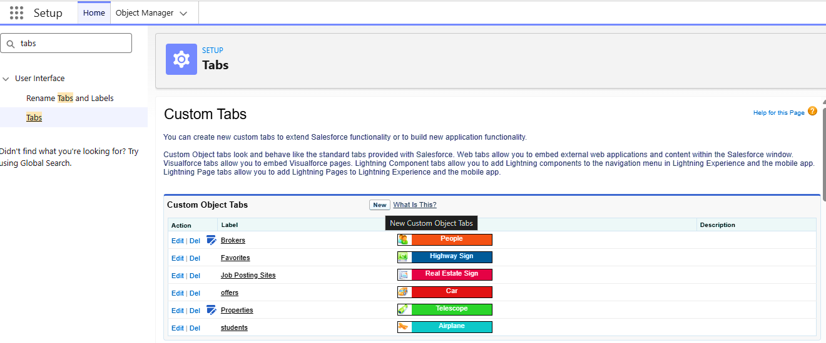
- Select Farmer as the Object.
- Choose a Tab Style.
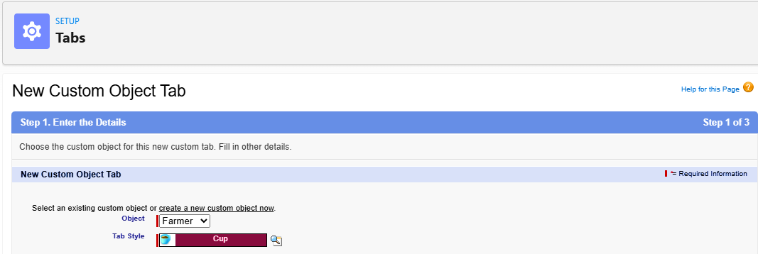
- Click Next.
- Select the required profile visibility.
- Click Next and then Save.

Activity 2:

Creating the Remaining Custom Tabs
Repeat the steps in Activity 1 to create tabs for the following objects:
- Farm
- Crop
- Crop Plan
- Irrigation
- Farm Activity
- Seed
- Fertilizer
- Pesticide
- Equipment
- Labour
- Harvest
- Resource
- Inventory
- Procurement
For each tab, select the corresponding object and choose a suitable Tab Style before saving.

Milestone 4 – Fields and Relationships

What are Fields and Relationships?
Fields are used to store information in Salesforce records. Relationships connect related records from different objects and help organize application data.

Activity 1:

Creating Fields for the Farmer Object
- Open Setup and select Object Manager.
- Select Farmer.
- Click Fields & Relationships.
- Click New.
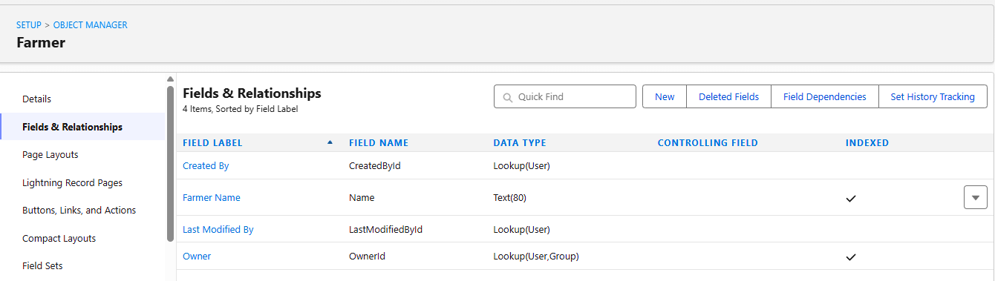
- Select the required data type.
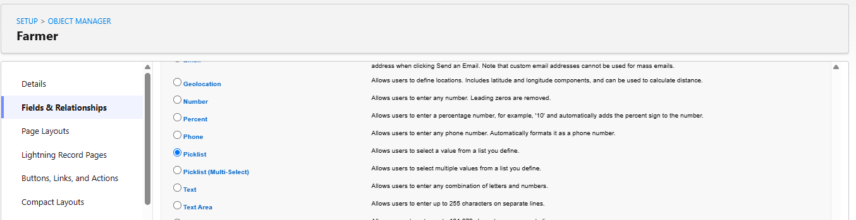
- Click Next.
- Enter the field label and configure its properties
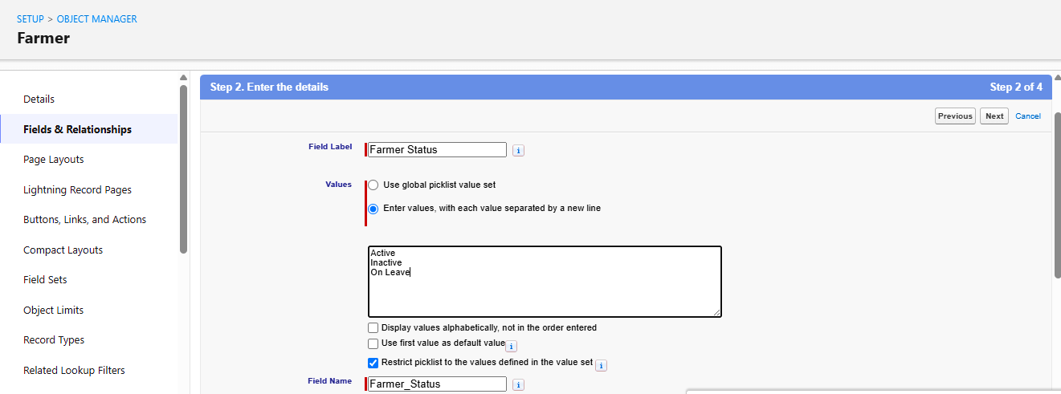.
- Click Next and save the field.
- Repeat the process for the remaining fields.
Fields created:
- Phone Number
- Email
- Address
- Farm Experience
- Farmer Status
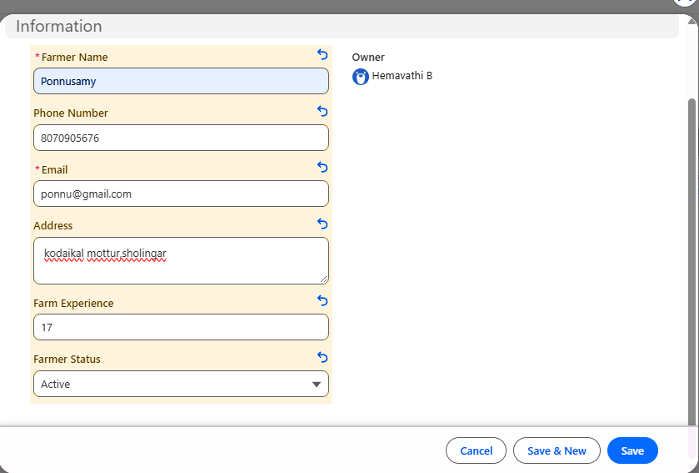

Activity 2:

Creating Fields for the Farm Object
- Open Object Manager from Setup.
- Select Farm.
- Click Fields & Relationships.
- Click New.
- Select the required data type.
- Enter the field label and configure the field.
- Click Next and save.
- Repeat the process for the remaining fields.
Fields created:
- Farm Location
- Total Area
- Soil Type
- Irrigation Type
- Farm Status
- Farmer

Activity 3:

Creating Fields for the Crop Object
- Open Object Manager.
- Select Crop.
- Click Fields & Relationships.
- Click New.
- Select the required data type.
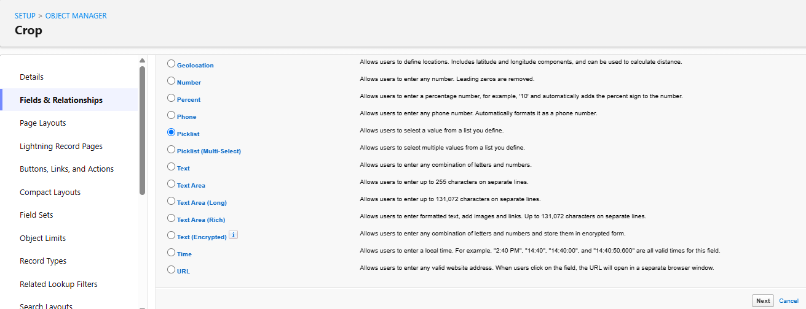
- Enter the field label and configure its properties.
- Click Next and save.
- Repeat for the remaining fields.
Fields created:
- Crop Type
- Crop Variety
- Growing Season
- Expected Duration
- Crop Status

Activity 4:

Creating Fields for the Crop Plan Object
- Open Object Manager.
- Select Crop Plan.
- Click Fields & Relationships.
- Click New.
- Select the required data type.
- Enter the field label and configure its properties.
- Click Next and save.
- Repeat for the remaining fields.
Fields created:
- Sowing Date
- Expected Harvest Date
- Planned Area
- Season
- Planning Status
- Farmer Name
- Farm Name
- Crop Name

Activity 5:

Creating Fields for the Irrigation Object
- Open Object Manager.
- Select Irrigation.
- Click Fields & Relationships.
- Click New.
- Select the required data type.
- Enter the field label and configure its properties.
- Click Next and save.
- Repeat for the remaining fields.
Fields created:
- Irrigation Date
- Water Quantity
- Irrigation Method
- Irrigation Status
- Notes
- Farm
- Crop Plan

Activity 6:

Creating Fields for the Farm Activity Object
- Open Object Manager.
- Select Farm Activity.
- Click Fields & Relationships.
- Click New.
- Select the required data type.
- Enter the field label and configure its properties.
- Click Next and save.
- Repeat for the remaining fields.
Fields created:
- Activity Type
- Start Date
- Due Date
- Activity Status
- Priority
- Description
- Farm
- Crop
- Crop Plan
- Farmer

Activity 7:

Creating Fields for the Seed Object
- Open Object Manager.
- Select Seed.
- Click Fields & Relationships.
- Click New.
- Select the required data type.
- Enter the field label and configure its properties.
- Click Next and save.
- Repeat for the remaining fields.
Fields created:
- Seed Type
- Seed Variety
- Quantity
- Unit
- Supplier Name
- Seed Status
- Farm
- Crop Plan

Activity 8:

Creating Fields for the Fertilizer Object
- Open Object Manager.
- Select Fertilizer.
- Click Fields & Relationships.
- Click New.
- Select the required data type.
- Enter the field label and configure its properties.
- Click Next and save.
- Repeat for the remaining fields.
Fields created:
- Fertilizer Type
- Quantity
- Unit
- Application Date
- Supplier Name
- Fertilizer Status
- Farm
- Crop Plan

Activity 9:

Creating Fields for the Pesticide Object
- Open Object Manager.
- Select Pesticide.
- Click Fields & Relationships.
- Click New.
- Select the required data type.
- Enter the field label and configure its properties.
- Click Next and save.
- Repeat for the remaining fields.
Fields created:
- Pesticide Type
- Quantity
- Unit
- Application Date
- Purpose
- Pesticide Status
- Farm
- Crop
- Crop Plan

Activity 10:

Creating Fields for the Equipment Object
- Open Object Manager.
- Select Equipment.
- Click Fields & Relationships.
- Click New.
- Select the required data type.
- Enter the field label and configure its properties.
- Click Next and save.
- Repeat for the remaining fields.
Fields created:
- Equipment Type
- Purchase Date
- Equipment Condition
- Maintenance Date
- Equipment Status
- Description
- Farm

Activity 11:

Creating Fields for the Labour Object
- Open Object Manager.
- Select Labour.
- Click Fields & Relationships.
- Click New.
- Select the required data type.
- Enter the field label and configure its properties.
- Click Next and save.
- Repeat for the remaining fields.
Fields created:
- Phone Number
- Labour Type
- Daily Wage
- Joining Date
- Labour Status
- Skills
- Farm

Activity 12:

Creating Fields for the Harvest Object
- Open Object Manager.
- Select Harvest.
- Click Fields & Relationships.
- Click New.
- Select the required data type.
- Enter the field label and configure its properties.
- Click Next and save.
- Repeat for the remaining fields.
Fields created:
- Harvest Date
- Quantity Harvested
- Unit
- Quality Grade
- Harvest Status
- Notes
- Farm
- Crop Plan
- Crop

Activity 13:

Creating Fields for the Resource Object
- Open Object Manager.
- Select Resource.
- Click Fields & Relationships.
- Click New.
- Select the required data type.
- Enter the field label and configure its properties.
- Click Next and save.
- Repeat for the remaining fields.
Fields created:
- Resource Type
- Quantity
- Unit
- Usage Date
- Resource Status
- Farm
- Description
- Farm Activity

Activity 14:

Creating Fields for the Inventory Object
- Open Object Manager.
- Select Inventory.
- Click Fields & Relationships.
- Click New.
- Select the required data type.
- Enter the field label and configure its properties.
- Click Next and save.
- Repeat for the remaining fields.
Fields created:
- Item Type
- Item Name
- Available Quantity
- Used Quantity
- Reorder Level
- Unit
- Stock Status
- Farm

Activity 15:

Creating Fields for the Procurement Object
- Open Object Manager.
- Select Procurement.
- Click Fields & Relationships.
- Click New.
- Select the required data type.
- Enter the field label and configure its properties.
- Click Next and save.
- Repeat for the remaining fields.
Fields created:
- Item Name
- Item Type
- Requested Quantity
- Supplier Name
- Requested Date
- Expected Delivery Date
- Total Cost
- Procurement Status
- Farm
- Inventory

Activity 16:

Creating Object Relationships
- Open Setup and select Object Manager.
- Select the object that requires a relationship.
- Click Fields & Relationships.
- Click New.
- Select Lookup Relationship or Master-Detail Relationship, according to the relationship configured for the object.
- Click Next.
- Select the related object.
- Enter the field label.
- Configure the remaining settings.
- Click Next and save the relationship.
Relationships connect the relevant records across Farmer, Farm, Crop, Crop Plan, Irrigation, Farm Activity, Seed, Fertilizer, Pesticide, Equipment, Labour, Harvest, Resource, Inventory, and Procurement.
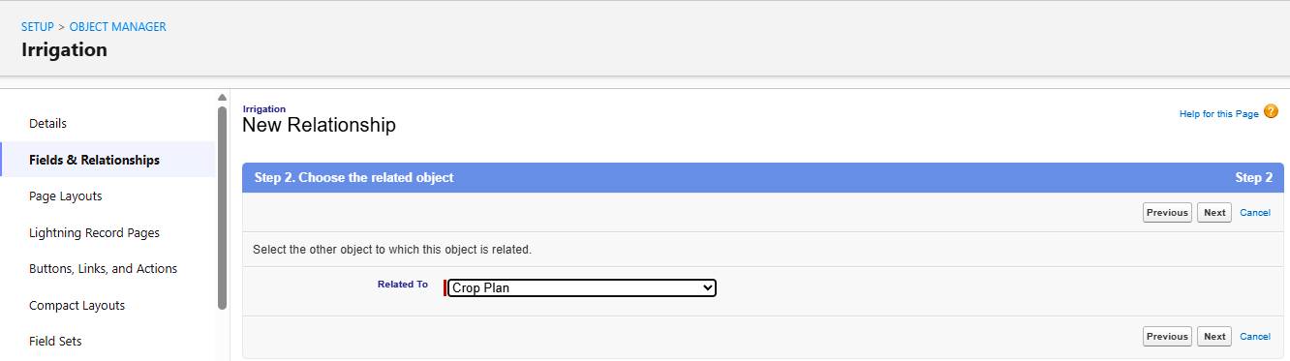

Milestone 5 – Validation Rules

What are Validation Rules?
Validation Rules are used to check record data before it is saved. They help prevent incorrect or incomplete information from being entered into Salesforce.

Activity 1: Creating a Validation Rule
- Open Setup.
- Select Object Manager.
- Select the object for which the validation rule is required.
- Click Validation Rules.
- Click New.
- Enter the Rule Name.
- Enter the error condition formula.
- Enter the error message.
- Select the error location.
- Click Save.
- Test the rule by entering invalid data.

Activity 2: Validating Farm Area
- Open Object Manager.
- Select Farm.
- Click Validation Rules.
- Click New.
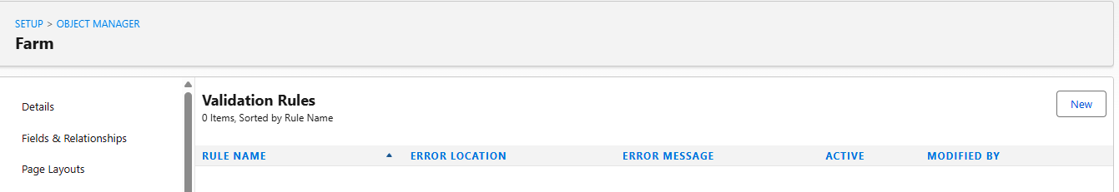
- Enter a suitable Rule Name.
- Configure the formula to prevent an invalid Total Area value.

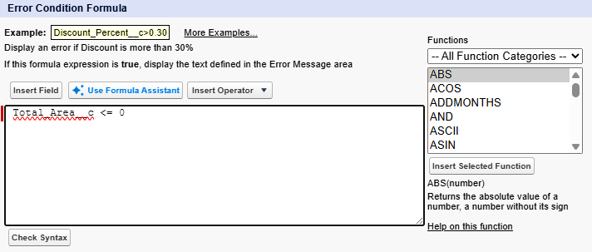

- Enter an error message.
- Select the error location.
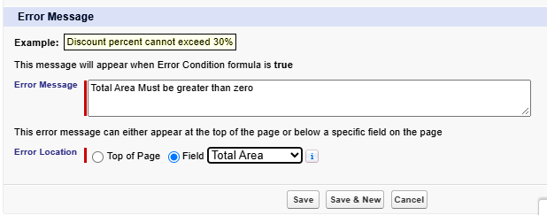
- Click Save.
- Test the rule by entering an invalid area.
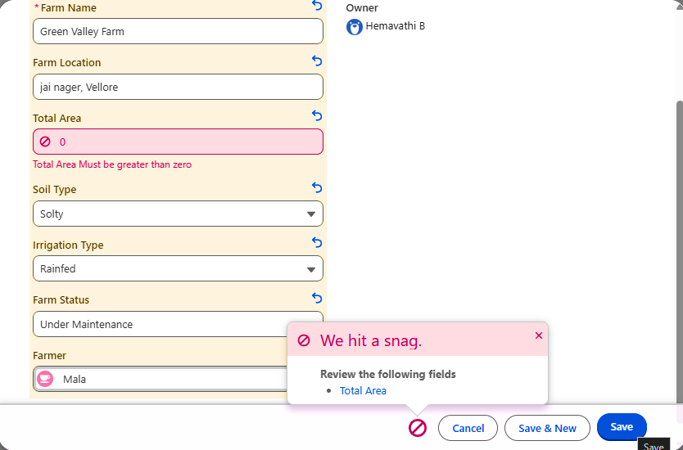

Milestone 6 – Reports

What are Reports?
Reports are used to display and analyze Salesforce records. They can be filtered, grouped, and summarized to provide information about farm operations.

Activity 1:

Creating a Report
- Open the Farm Management System app.
- Click the Reports tab.
- Click New Report.
- Select the required report type.
- Click Start Report.
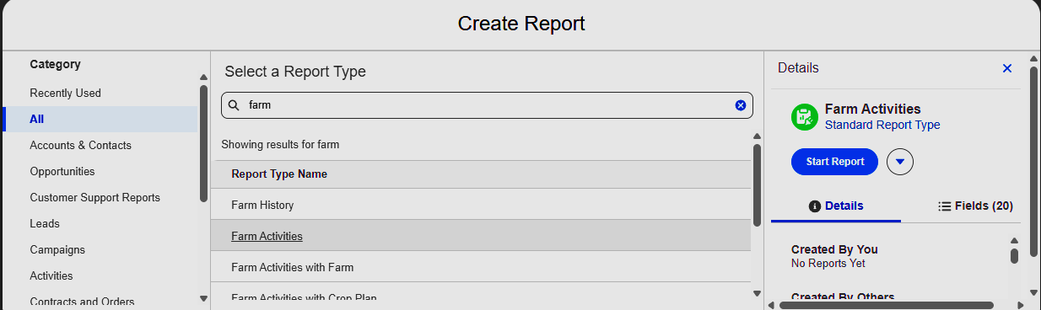
- In the Outline panel, add the required columns.
- In the Filters panel, configure the required filters.
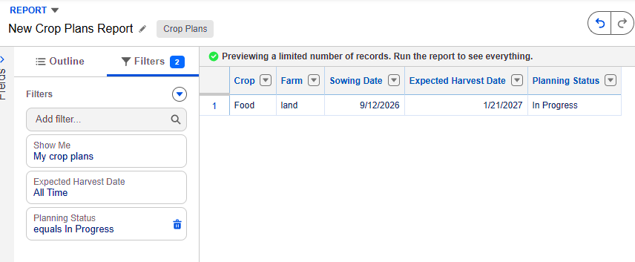
- Use Group Rows to group records when needed.
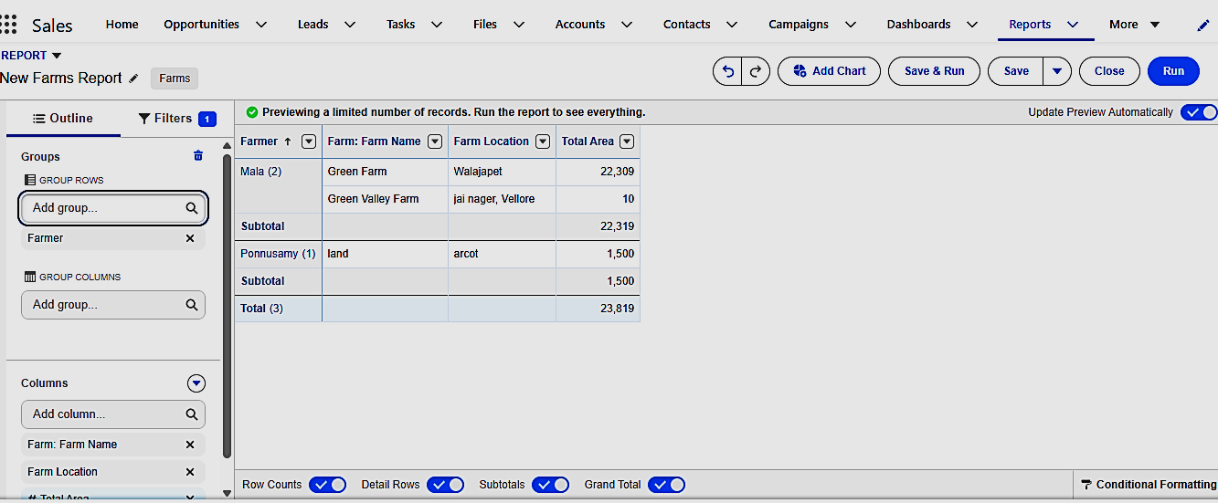
- Click Run to view the report.
- Click Save & Run.
- Enter the report name and select a folder.
- Click Save.

Activity 2: Creating Farm Management Reports
Create separate reports for the following modules using the same report creation steps:
- Farmer Details Report
- Farms by Farmer Report
- Crop Details Report
- Crop Planning Report
- Irrigation Report
- Farm Activities Report
- Seed Management Report
- Fertilizer Management Report
- Pesticide Management Report
- Equipment Management Report
- Labour Management Report
- Harvest Report
- Resource Usage Report
- Inventory Stock Report
- Procurement Report
Each report displays relevant records and fields from its corresponding object.

Milestone 7 – Dashboard

What is a Dashboard?
A Salesforce Dashboard displays summarized information from reports using charts, graphs, and tables. It helps users monitor farm operations and analyze important data.

Activity 1:

Creating a Dashboard
- Open the Farm Management System app.
- Click the Dashboards tab.
- Click New Dashboard.
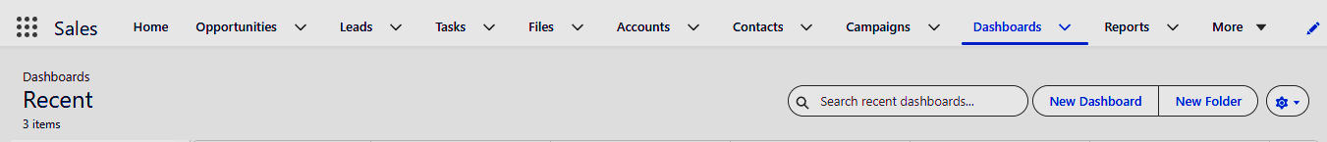
- Enter the Dashboard Name as Farm Management Dashboard.
- Enter a description if required.
- Select the required folder.
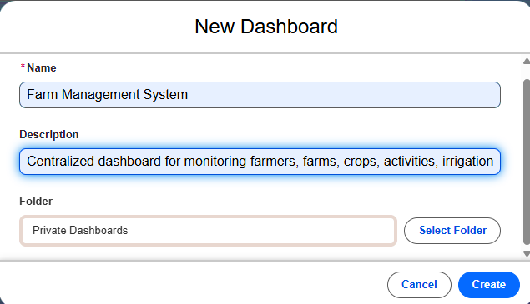
- Click Create.

Activity 2:

Adding Dashboard Components
- Open the created dashboard.
- Click + Component.
- Select the required source report.
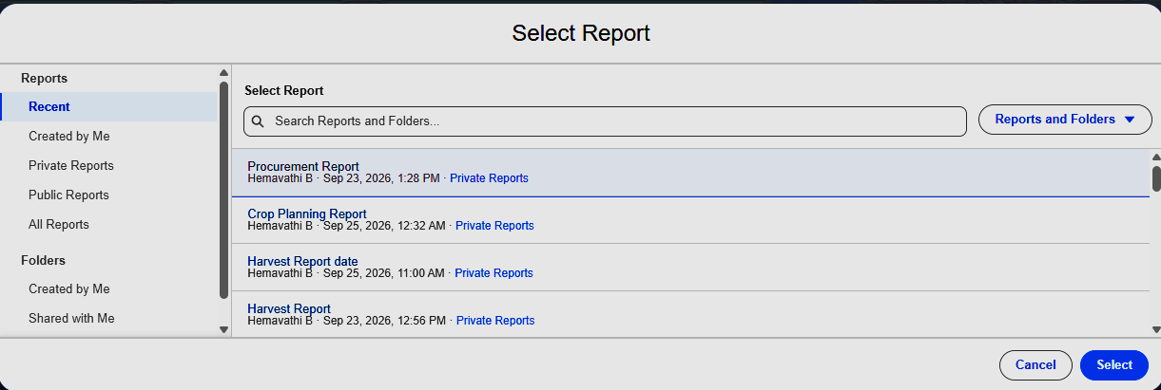
- Click Select.
- Choose the required chart type.
- Configure the chart properties.
- Enter a component title.
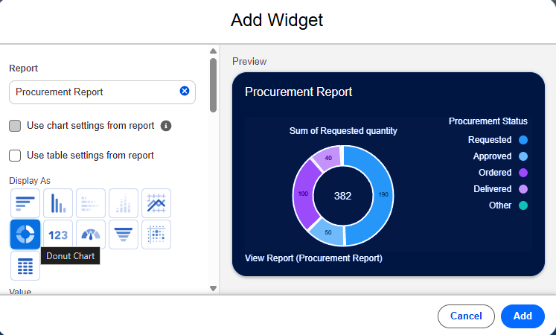
- Click Add.
- Repeat these steps to add more components.

Activity 3:

Adding Dashboard Charts
Add separate components using the relevant reports:
- Total Farmers
- Total Farms
- Crop Planning Status
- Farm Activity Status
- Inventory Stock Status
- Farm Area by Farmer
- Resource Usage by Type
- Procurement Status
- Harvest Performance by Crop
- Irrigation Water Usage
Choose suitable chart types such as metric, donut, bar, column, line, and table, depending on the report and available chart options.

OUR CREATED DASHBOARD

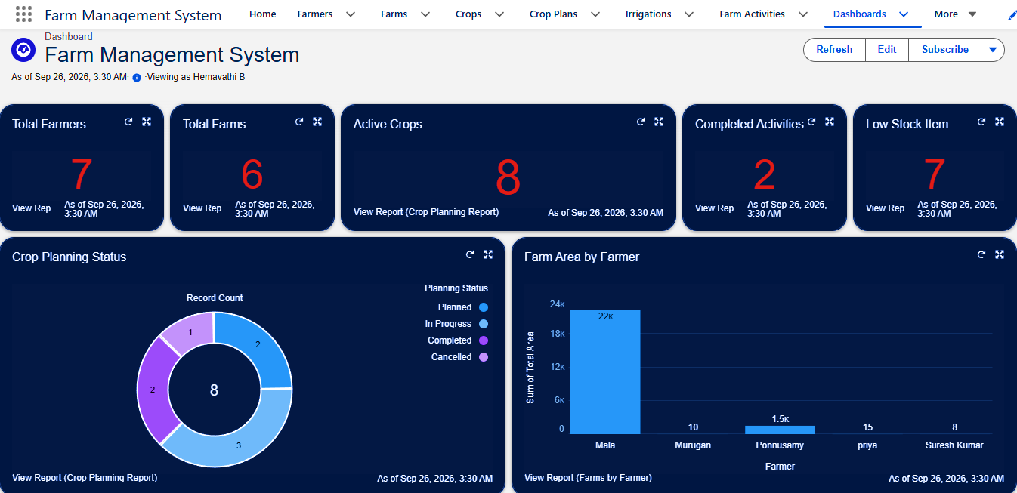

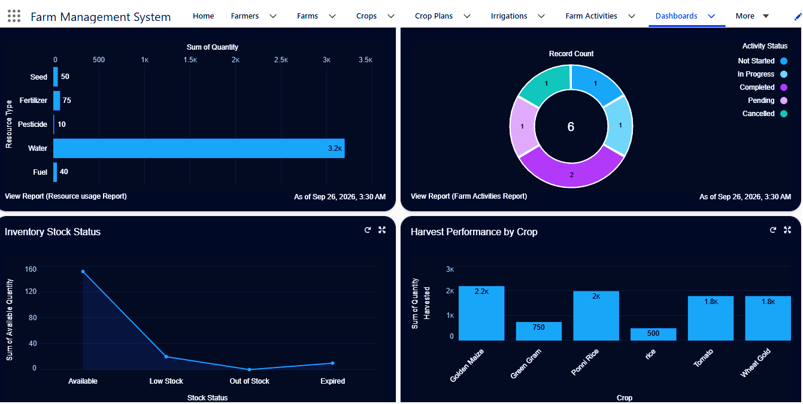

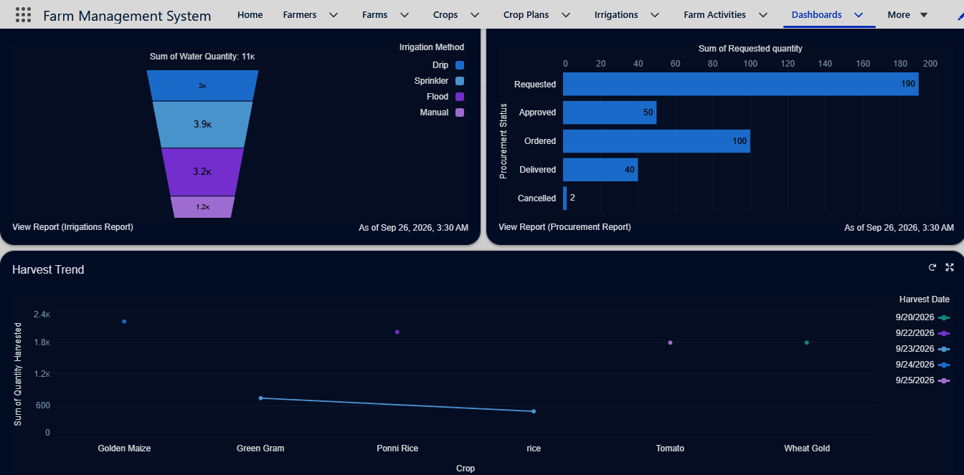

Activity 4:

Saving and Viewing the Dashboard
- Click Save after adding the components.
- Click Done.
- Open the dashboard from the Dashboards tab.
- Review the displayed charts and tables.
- Use Refresh to update the dashboard data when required.

Milestone 8 – Lightning App Manager

What is a Lightning App?
A Lightning App is a collection of tabs and tools organized in one place. It allows users to access different modules of the Farm Management System.

Activity 1:

Creating the Farm Management System App
- Open Setup.
- Enter App Manager in the Quick Find box.
- Select App Manager.
- Click New Lightning App.
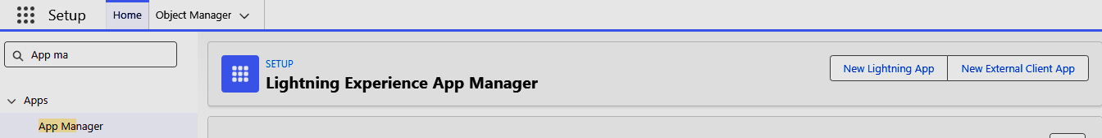
- Enter the App Name as Farm Management System.
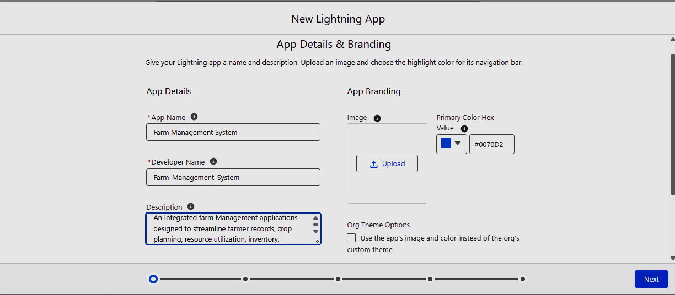
- Click Next.
- Configure the app options as required.
- Click Next.
- Configure the Utility Items if required.
- Click Next.
- Select the required navigation items.
- Move the selected items to Selected Items.
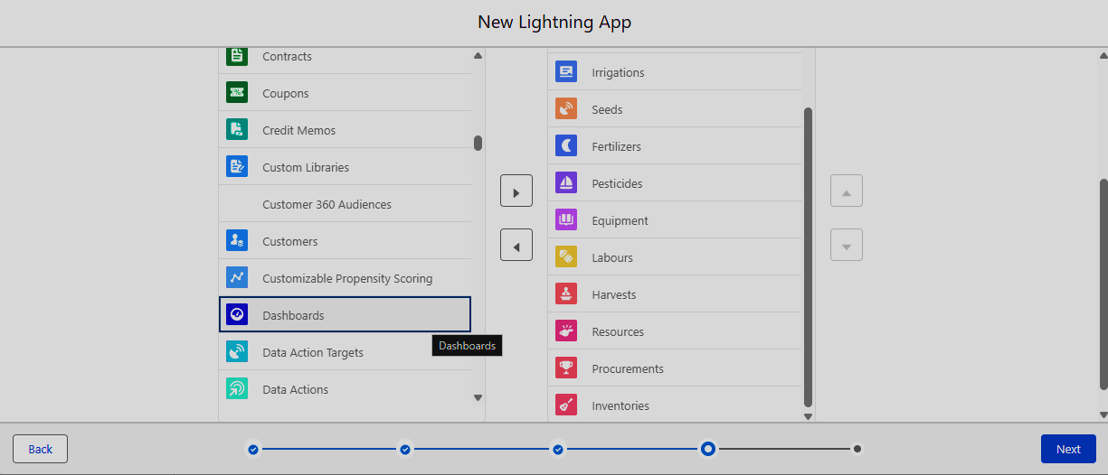
- Click Next.
- Select the profiles that need access to the app.
- Click Save & Finish.

Activity 2:

Configuring App Navigation
- Open Setup.
- Search for App Manager.
- Find the Farm Management System app.
- Click the dropdown arrow beside the app.
- Select Edit.
- Open the Navigation Items section.
- Add or remove the required tabs.
- Arrange the tabs in the required order.
- Click Save.

Activity 3:

Accessing the Application
- Open the App Launcher.
- Search for Farm Management System.
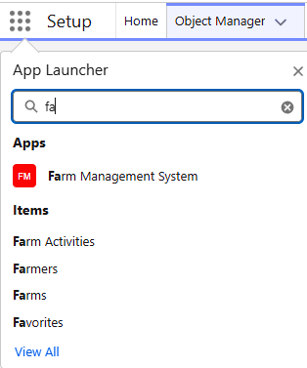
- Select the application.
- Verify that the navigation menu displays the required tabs.
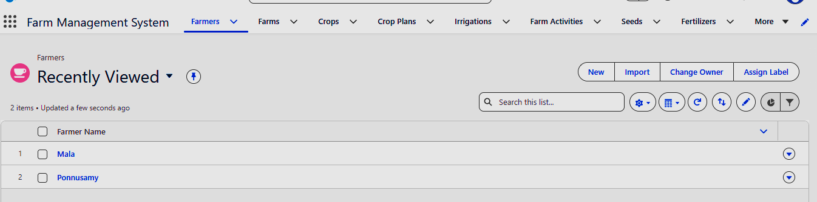
- Open each module and verify that its records are accessible.

7. FUNCTIONAL & PERFORMANCE TESTING

During the testing phase, the Salesforce interface was used to verify the functionality of the Farm Management System. The following were tested:

● Creation of Field, Crop Plan, Sowing Schedule, Irrigation Activity, Farm Activity, and Resource records

● Validation of input fields

● Relationship checks between related records

● Activity status and pending task verification

● Resource information verification

● Report generation

● Dashboard component verification

Performance testing was conducted to ensure smooth system response during regular record creation, data access, report generation, and dashboard operations.

8. ADVANTAGES & DISADVANTAGES

Advantages

● Centralized farm data management

● Reduced manual record keeping

● Organized field and crop information

● Better monitoring of farming activities

● Easy resource tracking

● Reports and dashboards for farm operations

● Improved farm planning

Disadvantages

● Requires an internet connection

● Depends on the Salesforce platform

● Salesforce configuration may require basic technical knowledge

● Offline access is limited

9. CONCLUSION

The Farm Management System successfully provides a centralized Salesforce-based platform for managing farming operations, field activities, crop planning, sowing schedules, irrigation activities, farming tasks, and farm resources. The system helps farmers organize agricultural records, track activity completion, monitor resource usage, and view important farm information through reports and dashboards. It reduces manual record keeping and supports better planning and monitoring of daily farm operations.

10. FUTURE SCOPE

● Mobile application integration

● AI-based crop prediction

● Weather information integration

● IoT-based field and irrigation monitoring

● Automated farming activity notifications

● Advanced crop progress analysis

● Market price information integration

11. APPENDIX

● Source Configuration: Salesforce Objects, Fields, Relationships, Validation Rules, Reports, and Dashboards

● Dataset: Field, Crop Plan, Sowing Schedule, Irrigation Activity, Farm Activity, and Resource Records

● Tools Used: Salesforce Developer Org

● Platform: Salesforce Cloud

Thank You

